**Day 2 (25-01-2022) Evening assignment**

1. Write C# code to find sum of n natural numbers. Read n from user.

Code:

using System;

namespace day2evnprogram

{

internal class Program

{

static void Main(string[] args)

{

int n, sum = 0, i;

Console. WriteLine("enter any number");

n=Convert.ToInt32(Console.ReadLine());

for(i = 0; i <= n; i++)

{

sum=sum+i;

}

Console.WriteLine("{0}",sum);

}

}

}

Output: enter any number

5

15

2. WACP to find factorial of a number

Code:

using System;

namespace fact

{

internal class Program

{

static void Main(string[] args)

{

int n, fact=1;

Console.WriteLine ("enter n value");

n=Convert.ToInt32 (Console.ReadLine());

for(int i=1; i<=n; i++)

{

fact = fact * i;

}

Console.WriteLine("{0}",fact);

}

}

}

Output:

enter n value

5

120

3. WACP to print factors of a given number.

Code:

using System;

namespace day2evnprogram

{

Internal class Program

{

Static void Main(string[] args)

{

int n, i;

Console.WriteLine ("enter any number");

n=Convert.ToInt32 (Console.ReadLine ());

for(i = 1; i <= n; i++)

{

if(n % i == 0)

{

Console.WriteLine(i);

}

}

Console.ReadLine();

}

}

}

Output:

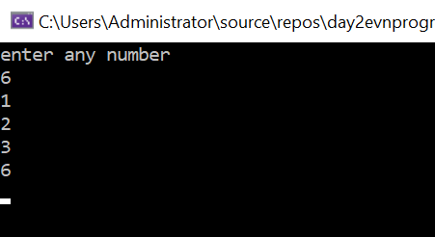

4. WACP to print multiplication table of a given number.[ using two ways discussed in the class .

Code:

using System;

namespace day2evnprogram

{

internal class Program

{

static void Main(string[] args)

{

int input, i;

Console.WriteLine ("enter any number");

input =Convert.ToInt32(Console.ReadLine());

for( i= 1;i <= 10;i++)

{

Console.WriteLine (input +"x"+i+ " = "+input*i);

}

Console.ReadLine ();

for (i = 1; i <= 10; i++)

{

Console.WriteLine("{0}x{1}={2}",input,i,input*i);

}

Console.ReadLine();

}

}

}

Output:

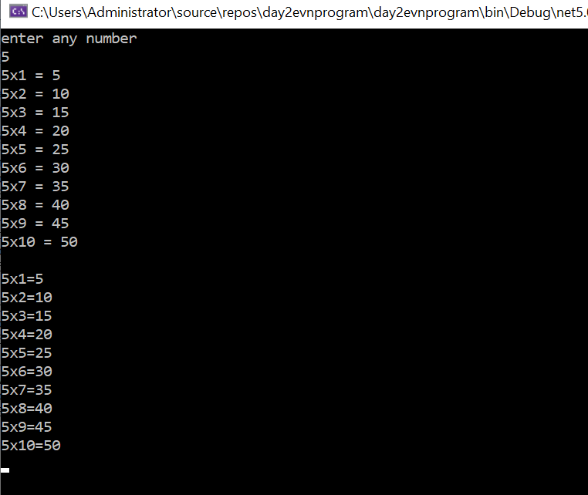

5. Write CSP to print Hello 5 times using while loop.

Code:

using System;

namespace day2evnprogram

{

internal class Program

{

static void Main(string[] args)

{

int i=1;

while(i<=5)

{

Console.WriteLine("hello");

i++;

}

}

}

}

Ouput:

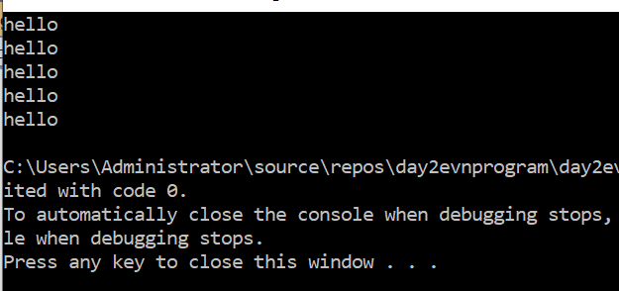

6. WACP to print multiplication table using while loop

using System;

namespace day2evnprogram

{

internal class Program

{

static void Main(string[] args)

{

int input, i=1;

Console.WriteLine ("enter any number");

input = Convert.ToInt32(Console.ReadLine());

while (i<=10)

{

Console.WriteLine(input + "x" + i + " = " + input * i);

i++;

}

}

}

}

Output:

